Create a script named as "pass_validate.sh" to validate the user's provided input
password as:
Password policy rules:
1) Weak passwords
- Are between 1 and 7 characters long (inclusive)
- Contain only letters (a–z, A–Z) and digits (0–9)
- Do not contain any special characters, spaces, or other symbols

2) Normal passwords
- Are between 8 and 12 characters long (inclusive)
- Contain only letters (a–z, A–Z) and digits (0–9)
- Do not contain any special characters, spaces, or other symbols

3) Strong passwords
- Contain at least one special character
(Allowed special characters in this lab: ! @ # $ % ^ & * ( ) _ + - = )
- Can be any length
- Can contain letters, digits, and/or the special characters listed above
----------------
The command vim pass_validate.sh is used to create or open a Bash script named pass_validate.sh in the Vim text editor. In this script, password validation rules are written using conditional statements. The script checks whether the entered password is weak, normal, or strong.
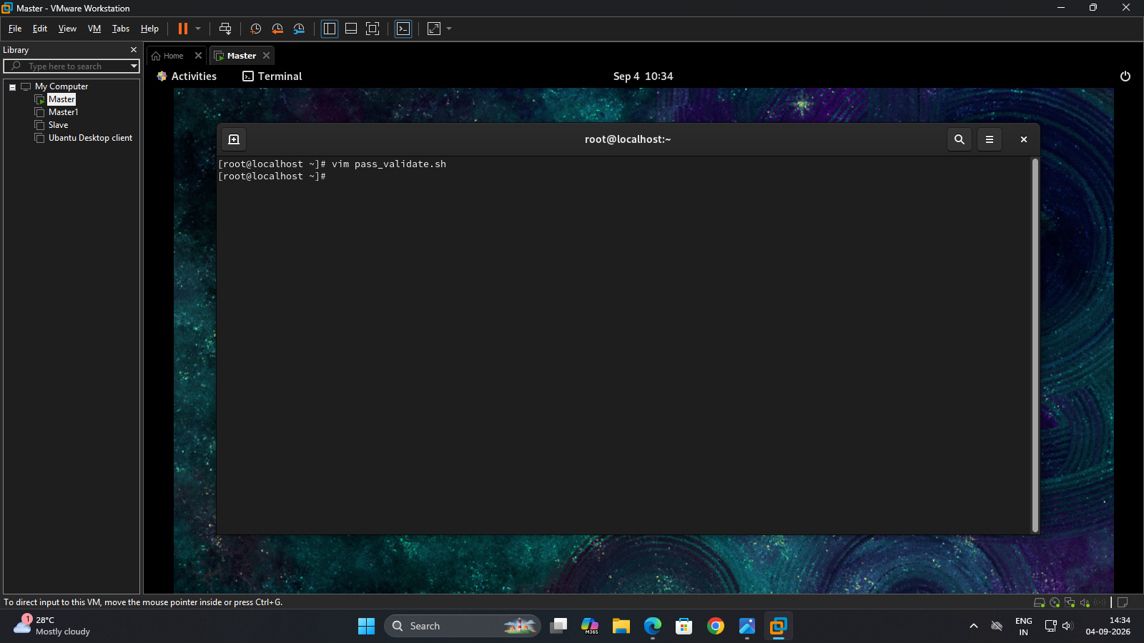

The command :wq is used in Vim to save the changes and quit the editor. After returning to the terminal, the command bash pass_validate.sh is used to execute the Bash script. The script prompts the user to enter a password and then checks it according to the defined validation rules.
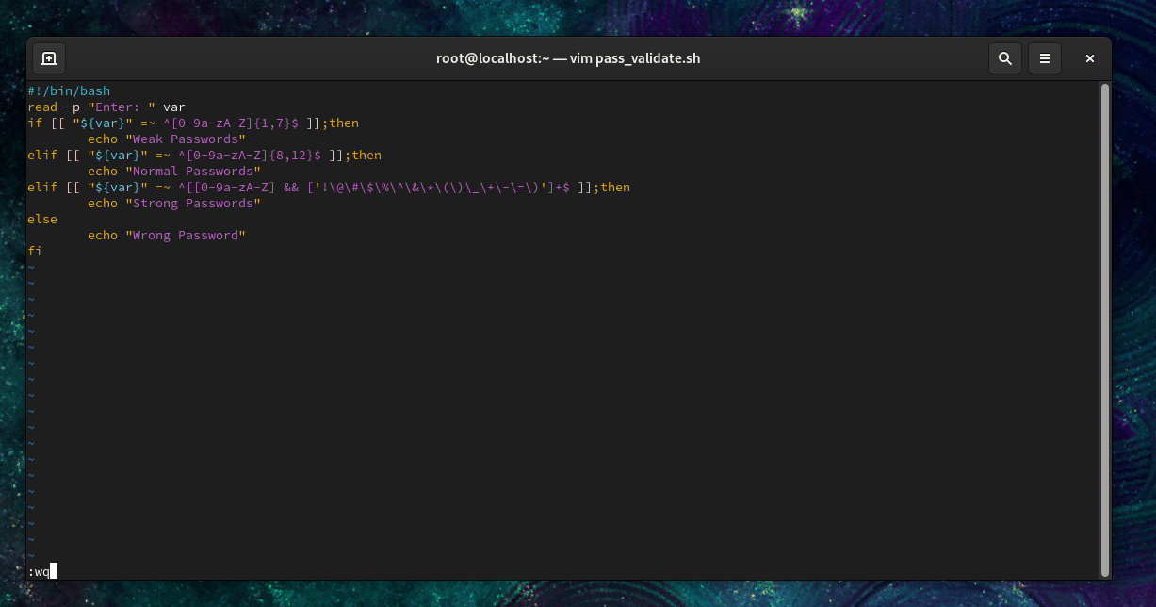

The command bash pass_validate.sh is executed three times to test different passwords. The password pg270 is classified as a Weak Password, prajwal27 is classified as a Normal Password, and Prajwal@27 is classified as a Strong Password. This demonstrates that the script successfully validates passwords based on their length and the presence of special characters. 